**INTERNSHIP REPORT**

AUGUST 2022 to DECEMBER, 2022

**Assets Warehousing Application**



Submitted by

**Atharva Deepak Amrutkar 21910003**

**Yogesh Sakharam Diwate 21910996**

**Tejas Rajendra Shinde 21910899**

Under the Guidance of

**Dr. Pravin Futane**

**Professor and Head of department**

**Department of Information Technology**

**Vishwakarma Institute of Information Technology, Pune**

**Academic Year 2022-23**

**Department of Information Technology, Vishwakarma Institute of Information Technology, Pune Academic Year 2022-23**

**CERTIFICATE**

## **ACKNOWLEDGMENTS**

We like to share our sincere gratitude to all those who help us in completion of this project. During the work we faced many challenges due to our lack of knowledge and

experience but these people help us to get over from all the difficulties and shape our project.

We would like to thank Prof. Pravin Futane for his guidance , because of which our whole team was able to learn the minute aspect of project work.

In the last , we would like to thank management of Information Technology department of Vishwakarma Institute Of Information Technology for giving us

such opportunity to learn from these experiences

Thank you all,

21910003 Atharva Amrutkar.

21910996 Yogesh Diwate,

21910899 Tejas Shinde

## 

## **ABSTRACT**

Living an increasingly digital life a twenty-first century individual may possess a large amount of digital,tangible & intangible assets. Many of which may be only accessible through a digital account. For example, an individual could have an email along with a financial account, business account,gold repository,shopping account, and numerous other accounts with virtual property. Locating digital property can be a tough task for heirs as they are less likely to stumble upon an unknown digital property than an unknown physical property.

There is a need to combine tangible assets(car, furniture, jewellery, art, clothing, appliances) and intangible assets(stocks, bonds, patents, trademarks, copyrights) on a single platform. There is need to have a platform in which all types of assets can be managed and it can be easy for heirs to get their deceased ones assets.Our methodology helps to track all the financial transactions runtime and updating the assets along with providing SOPs(Single point of Contact) for intangible assets for their heirs via fingerprint access.

## 

## 

## 

## 

## 

## 

**TABLES OF CONTENTS**

**ACKNOWLEDGMENTS** **2**

**ABSTRACT** **3**

**Chapter 1: Introduction** **2**

1.1 Motivation 2

1.2 Outline of Project 3

1.3 Organization of report 4

**Chapter 2: Literature review** **5**

2.1 Existing literatures Overview 5

2.2 Existing System and our solution 8

**Chapter 3: Proposed Methodology** **12**

3.1 Presentation layer (View layer) 12

3.2 Business Layer (View-Model Layer) 14

3.3 Data Layer (Model Layer) 15

**Chapter 4: Implementation** **16**

A. Dynamic updation of banking transaction data using SMS 16

B. Adding Nominee to user 17

C. Static pop ups 18

D. Database Description 18

E. Uploading files 18

**Chapter 5: Result and analysis** **19**

**Chapter 6: Conclusion** **21**

6.1 Conclusion 21

**Chapter 7: References** **21**

## 

**LIST OF FIGURES**

| SRNo. | FIGURE NAME | PAGE No. |
| --- | --- | --- |
| 3.1 | 3-Layered MVVM Architecture of Application | 13 |
| 3.2 | WorkFlow of Application with Database using MVVM Architecture. | 14 |
| 4.1 | Flowchart of dynamic updation of bank assets | 16 |
| 4.2 | Add nominee flowchart | 17 |
| 5.1 | Nominee added screen | 19 |
| 5.2 | Nominee does not exist error screen | 19 |
| 5.3 | Last transaction updated screen | 19 |
| 5.4 | Before SMS View bank asset screen | 20 |
| 5.5 | Close view of before SMS screen | 20 |
| 5.6 | After sms View bank asset screen | 20 |
| 5.7 | Close view of after SMS screen | 20 |

**LIST OF Tables**

| Sr.No | Table name | Page no |
| --- | --- | --- |
| 1 | Existing system and Proposed Solution | 8-11 |

## 

## Chapter 1: INTRODUCTION

### 1.1 Motivation

There is an assumption that one's digital assets are not of that importance. because they do not take up virtually any physical space and they are not seen like everyday objects. In this modern age, as we live digital life ,digital assets grow. Assets are pretty easy to organize when you are alive, but they can be a nightmare if you lose a password,document or if you die. This is partly because the giant technology firms that your assets are in do not want to interact with you directly. Given a vast amount of assets in the twenty-first century ,someone can easily overlook writing will for digital assets. According to a recent survey [12] , the amount of digital assets of the average person is believed to be around $55000 .

It is easy for heirs to get or find their physical assets as such properties are easy to find. Whereas locating or finding digital assets is hard and can be troublesome. Even if heirs have knowledge about digital assets, liquifying them or transferring them can be a difficult task if not handled properly.

DigiLocker[14] provides only storing and accessing legal documents making its scope extremely limited in terms of the executor's point of view. In case of DigiLocker, the executor will not only have to Figure out whom to contact to document all the assets but also will have to compute the value of those assets in terms of present day valuations. Moreover, there’s a possibility of the decedent not being able to store all the financial information in DigiLocker completely. Also, this sensitive information may land up in the wrong hands.

KhataBook[15] acts as a cash book that needs to be updated manually of all the transactions that the user does. So, in terms of maintaining all the financial records it has a limited scope because it fails to document real-time transactions without manual interventions.

There are applications like Digilocker and khatabook but there is a need for applications which can serve the benefits given by both applications.There are presently no explicit laws or regulations governing the transfer of digital assets in India. It is unclear how the Information and Technology Act, 2000 applies to digital assets that are given or inherited through wills. Additionally, digital assets are not mentioned in any of the appropriate Succession Acts or modifications in the nation. [11]

In such a situation of not having proper procedure for transferring digital assets, digital will can be an informal documentation for helping heis to deal with his/her digital assets. Managing Assets , their liquidation, these things can be troublesome for an individual if he has a plethora of assets . Different assets have different liquidation methods . So there is a need for an application that can support all types of assets and can be useful for users to liquidate them .

### 1.2 Outline of Project

In this report, we try to demonstrate an asset warehousing application that will act as an e-register for all the assets(tangible & intangible). Everyone should think about creating an electronic register for all of their digital assets while doing estate planning. This practical solution to this problem is that one can warehouse all his/her assets in an Digital Asset Warehousing application and just like bank nomination or property nomination’s work, the user’s account’s assets or property assets can nominate someone to access the data after their demise.

To pass on your digitally warehoused assets is to nominate some close relative who would be inheriting the user’s (decedent's) wealth post demise there lies an inherent risk that these crucial warehoused financial data may land up in some wrong hands if passwords are not maintained securely. To tackle this challenge we have added a Fingerprint access for the nominee’s of the assets. Our proposed application will not only warehouse the documents of the assets in digital form but also will compute the total real-time asset valuation of all the assets as per the present day rates. Moreover, it will fetch and update all the bank transactions data in real-time through granted SMS access through to the user’s registered device.

Our application can provide Financial insights based on the financial data inserted to the user or nominee how he/she can liquidate that assets as soon as possible by contacting the Single point of contact (SOPs) added by the user before his/her demise. Moreover, an annual report will also be generated based on that information for the user. We will be storing all the data in a NoSQL Firebase realtime Database that can allow fast and secure access to the data. Our proposed application will be based on MVVM Architecture that will have a View-Model layer as the middle layer between View and Model layer.

Because the existence of digital assets is a relatively recent development, there is a lot of confusion regarding how to handle these properties using a digital Will among the public and the law. Given this uncertainty, this Proposed method is an attempt to Digitally warehouse all the assets of an individual and associate these assets with a nominee to access post demise of the user and to seek clarification where the law stands in terms of Digital will is concerned.

### 1.3 ORGANIZATION OF REPORT

This report Consists of following chapters

* Introduction
* Literature Review
* Proposed methodology
* Implementation of Project
* Result and analysis
* Conclusion
* References

## 

## 

## 

## 

## 

## 

## 

## 

## CHAPTER 2: LITERATURE REVIEW.

### 2.1 Existing literatures Overview

Current trend is that mobile applications and cloud storage are making a good combination for application development. Using this trend or combination many applications are being launched considering the best experience for end users. To provide good user experience and fulfill project demands backend is very important and have dominant role.[2]

Divya Sharma et al. in [2] built an application infrastructure with firebase as a mobile backend. To demonstrate Firebase's functionality and its use as the finest mobile backend-as-a-service, an Android application with Firebase as the backend was constructed for this study. The primary goal of the work is to demonstrate the benefits, advantages, and constraints associated with the use of Firebase. Additionally, they have worked on comparing other BaaS platforms and developing better apps with Firebase as the backend. They concluded that using firebase as a backend provides reliability, conformability for users and simplicity.

Margaretha Ohyver et al. in [1] created Toddlers daily nutritional needs app to compare performance of firebase Realtime database with MySQL database. This exam was administered using the Wilcoxon Signed-Rank test. They compared testing performance times for all of the CRUD operations in order to compare the two databases. They ran each batch of tests 50 times from one to 3000 records. Based on the Wilcoxon Signed-Rank test of the comparison between Firebase Realtime database and MySQL Database, they concluded that Firebase Realtime Database is more suitable for their project. For each CRUD operation firebase Realtime database has better response time compared to MySQL database. Additionally, they concluded that Firebase offers Realtime Database and streamlines backend operations, enabling developers to construct applications without worrying about server side.

In paper [5] ,Authors have discussed fingerprint authentication in mobile. In this paper, they investigated how the fingerprint security feature on mobile devices can provide security for web login. They introduced a program which generates a single time password using fingerprint and IMEI number of registered mobile devices. They concluded that fingerprint authentication is very secure for web based applications.In this paper , pass SDK has been used. Pass SDK stores fingerprints and it also matches fingerprint with registered fingerprint .In paper[5] , we identified that there is need of an IMEI number for fingerprint authentication.If this need is eliminated then it could be easy to login on multiple devices using the same fingerprint.[5]

In paper [4], Authors have discussed various applications based on incoming SMS.This paper describes various applications that can be performed by interpreting sms .This can work by just sending a text sms to that mobile.Their work included fetching location, auto respond on incoming text messages.This application uses services like telephony, location based Services (LBS) and native android applications. Major gap that we identified in this paper is that response time if multiple messages are received is lower and that can be improved.[4]

G Dhanush et al. in [3] developed a mobile application which was to establish interaction between faculty and college students. In that application, they gave features like document uploading portal, attendance system etc. They integrated the user interface with firebase to avail all features. In this application they used firebase storage to store documents in the form URL token that is generated by firebase. Any student can access those files through in-app access. In this paper, authors have tried to make an application that will reduce efforts that occur in traditional management systems. They concluded that working with the Firebase Realtime database system is easy for applications that require users to upload and view files.

An asset that has a finite monetary value and usually a physical form is a tangible asset. Tangible assets can be liquified for some monetary value through that assets market value. Bank assets,property,gold are all tangible assets in physical form.[13] financial assets such as stocks,mutual funds,insurance,bonds which derive their value from contractual claims are also considered tangible assets[10]

Bank assets are the most liquid assets.They are instantly converted to cash. Bank assets can be easily transferred to nominees accounts . Property is ILLiquid asset. Illiquid assets are the ones that are very hard to liquify.property has registration number generated after stamp duty is paid. The RERA Act 2016 has made it mandatory for promoters to register their real estate project to sell, advertise, market, book, or purchase it under the conduct of the Maharashtra Real Estate Regulatory Authority. So property which is registered under rera has a rera registration number which can be used to to avoid any fraud with property buyer.These parameters are considered for property entities in our application.

For gold we have considered the type of gold,gold price and certain more parameters in our research. In paper [6],[7] authors have discussed relation between stock and gold.As stock market falls gold price increases so it works as a defensive asset.In paper[6] they have concluded gold is a good portfolio diversifier and a hedge against stocks as well as a safe haven in extreme stock market conditions . Type Of gold investment impacts return from gold assets

Stocks are operated and controlled by SEBI. for Keeping stocks in electronic format demat account is required. Demat account number helps in getting all stocks at one place.Stocks are very volatile . In paper [8] authors have researched and derived how fundamental factors affect future stock prices.They concluded that Return on Assets(ROA) has a positive impact on stocks whereas Debt to Equity Ratio(DER),Current Ratio(CR) does not affect stock price . Nominee can transfer shares to his demat account by giving offline application to sebi.

Mutual funds have scheme names and scheme code which are used to identify mutual fund schemes. Mutual funds can be categorized as lump sum and sip. In Lump Sum a certain amount is paid upfront whereas in Sip monthly installment is compounded to get benefit of compounding.folio number is unique number associated with user account and mutual fund. Mutual funds generally carry less risks than stocks as they invest in a wide range of investments. Mutual funds can be liquified in 2 days. They can be transferred to nominees with ease.

Intangible assets are assets that are not physical in nature and very difficult or impossible to liquify. Trademark,copyright,patent are such intangible assets.There are two types in intangible assets one is definite other is indefinite .Brand name is an example of indefinite asset as it stays for a long time. Copyright, patent are definite assets that are needed to renewed after certain period of time.[9]

Trademark, patent, Copyright all come under Intellectual property rights in india.Trademark is issued in trademark journal published every week . If Objections are not raised then TM number is generated and trademark can be used now. All trademarks are valid for 10 years in India. For copyright validity is 60 years. Copyright number is generated for every copyright. To file a patent one must fill a patent application form . Then the patent will be examined for patentability. If objections are raised by the Patent office then applicants need to address those objections. After resolving objections, the patent will be published after 12 months. The validity of the patent is 20 years.

### 2.2 Existing System and our solution

| SR.NO | FEATURE | OUR SOLUTION | DIGILOCKER | KHATABOOK |
| --- | --- | --- | --- | --- |
| 1.] | MANAGE ASSETS. | ● Store all types of Assets(digital,tangible & intangible) in JSON format including documents in PDF format.  ● Uses NoSQL Firebase Realtime Database to Store , Fetch and Update Assets in RealTime.  ● Uses Firebase Secure Cloud storage to store relevant documents for nominee’s and unique Document URl is generated in User’s DB. | ● It is an ecosystem for eDocumentation, which stores only PDFs Documents.  ● Uses Machine-readable format adhering to XML Structure for application usage.  ● Documents need to have a common set of meta-attributes such as issuerID,DocID,issueDate to Fulfill the XML structure. | ● It is a bookkeeping application to store all the financial transactions statically.  ● Uses Cloud-Based Database to store Manually entered data.  ● Relies on Third-Party Infrastructure service providers to manage Data of the users. |
| 2.] | Shareability. | ● Acts as Digital Will for the inheritor of the assets for the Nominee Users added by the Admin User.  ● Data of all the assets in the form JSON tree is cloned to the account of the nominee(inheritor) account by the Admin User once the existence of the Nominee User is verified. | ● Users can share their documents with other agencies just by providing the unique URl without having to share photocopies.  ● Sharing is possible on feature phones via SMS and text-based systems. | ● All the manually added list of transactions can be shared to the staff by adding their phone numbers registered on Khatabook application. |
| 3.] | Security. | ● A dedicated secure space for each individual user to store and access data regarding his/her assets and documents.  ● Unique **URl** for the documents stored in the form of PDFs are crucial in maintaining globally unique and persistent.Incase the resource is unable to access or becomes unavailable.  ● Fingerprint Authentication is required for the nominee’s to access the Asset Details shared by their decedends. | ● Exposes a Standard **REST API** for realtime access to the eDocuments.  ● The **DLTS** solution allows issuers to secure access via **Aadhaar authentication** of any of its owners.  ● All e-documents need to be “**Digitally signed**” by the issuer to ensure they are verifiable for authenticity and unaltered. | ● Third-Party Service provider employs separation of environments and segregation of duties and has a strict role-based access control.  ● The data stored is protected by application-level encryption.  ● They enforce key management services to limit access to data. |
| 4.] | Dynamic Updation. | ● Implementation of **BroadCastReceiver Algorithm** to Fetch relevant data from realtime SMS and dynamically update the valuation of that particular asset.  ● Immediate valuation for **Liquidation** of relevant recognized assets. | ● No such functionality available in terms of scope of the Digilocker application. | ● Every transaction needs to be updated manually either by the Admin User or its staff. |
| 5.] | Fingerprint authentication | ● Fingerprint access to the nominees of the assets added by the admin user, to avoid leaking of sensitive information in wrong hands. | ● Digilocker does not have feature of fingerprint access | ● Direct access to the transactional data inserted.No Functionality for Fingerprint access. |

## 

## 

## 

## Chapter 3: Proposed Methodology

In the twenty-first century, where most of the global transaction occur via mobile applications, it would be highly beneficial for users & nominee’s (executor) who are interested in warehousing all of their assets, to rely on a secure mobile application which not only be able to dynamically update their bank assets using SMS scrapping but also will be able to store their crucial financial data securely using fingerprint access of the nominee of the respective asset. So, In this method we have proposed to use MVVM architecture for the android application which will have a View-Model layer which acts as a interface between model layer which only access to the database and the View layer which is responsible for getting user requests and redirects them to View-model layer that fetches it from the Model layer.

### 3.1 Presentation layer (View layer)

The View layer's function is to communicate with the View Model layer about the user's action. This layer only keeps track of the View Model; it does not include any application logic. This layer essentially primarily pertains to user interface design and design quality factors. Only through this layer's gateway can a user interact with the programme and have his or her needs met. We have utilized Linear Layout, Relative Layout, and Constrained Layout in our application. These layouts are very important for building UI.

As given in fig. 3.1 in the Presentation layer we have three main screens one is login screen, second is user portfolio screen and third is dashboard screen. Login screen will have options for users to login with a mobile number, login with a fingerprint and register as a new user. There will be three separate screens for all these activities. User portfolio screen will lead to add assets screen, display assets screen, fetch last transaction, delete asset screen, and update asset screen. The Add asset screen will have the option to add tangible and intangible assets. Dashboard screen will lead to user profile screen, add nominee screen, generate annual report screen. User profile screen will display all user information.

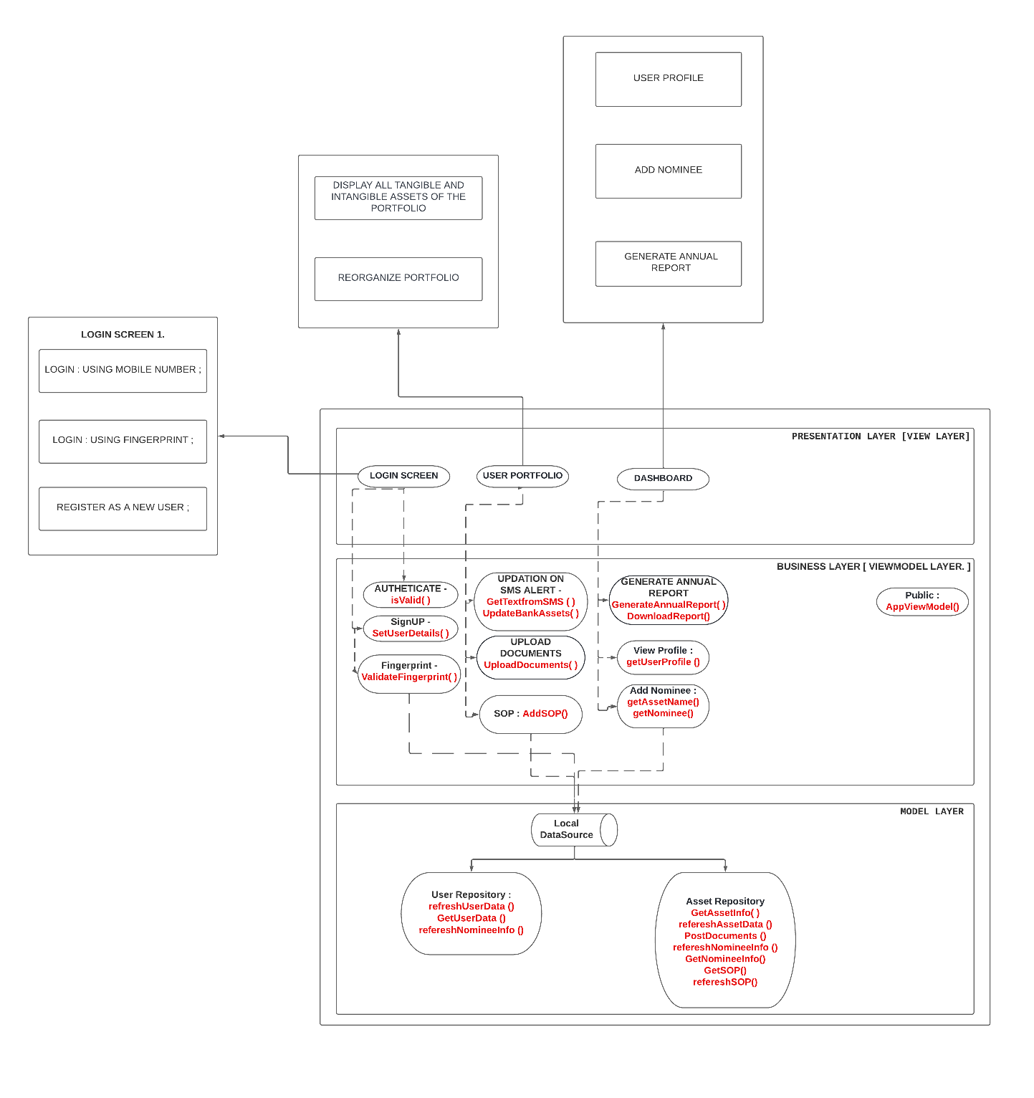

Fig. 3.1: 3-Layered MVVM Architecture of Application

### 3.2 Business Layer (View-Model Layer)

This layer primarily focuses on algorithms and the various data collecting frameworks that have been employed. Figure 3.2 illustrates the workflow/procedure for pulling and uploading data to the database architecture. Java collection frameworks must be precise and quick in order to process data and render it in the view layer. We used Hash Maps, one of the features in the Collection framework, to fetch data from Firebase. Hashmap was a tremendous help because it has the key-value pair functionality that is frequently required for JSON in Firebase. To render the data into the view tier, List objects, Adapter classes, and hash maps were also used.

View Model Object will provide data to the UI components like fragments or activities. It also includes an observable data holder called the Live Data that allows View Model to inform or update the View whenever the data gets updated. It is very crucial, mainly to keep our application from reloading on orientation changes. We create observables for the View, and it decouples from the view i.e. View Model shouldn't be aware about the view who is interacting with. In Figure 1., we can observe that View object in Presentation Layer has various UI component activities like User Profile linked to getUserProfile() class , in order to facilitate the job of the View Model, a AssetRepository class is created to interact with Database in Model Layer and finally provide a Live Data object for View Model. AssetRepository is the Data Provider for View Model, it has getUserProfile() which simply wraps the response into Live Data Object.

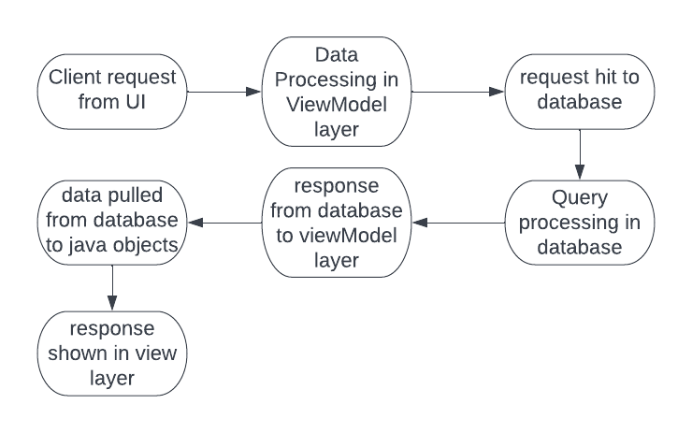

Fig. 3.2: WorkFlow of Application with Database using MVVM Architecture.

### 

### 3.3 Data Layer (Model Layer)

Model layer is all about database infrastructure. For the model layer, Firebase offers a variety of functions. However, we have mostly used three of them: Firebase Realtime Database, Firebase Authentication, and Firebase Storage Bucket.The firebase storage bucket is concerned with the upload files feature. Firebase authentication is to authenticate users and to log them. Firebase provides processing power of real time data , that is changes in database will happen real time and no delay and sync time to cloud is very less. The upload speed of documents will be dependent on internet speed.

The data layer is in charge of abstracting the data sources. To get and save the data, the model and viewmodel collaborate. In the Model layer there are two main nodes in the database, one is user and another is nominee. When an asset is added to the user , an asset object is created and is added to the user node. User database has two tables descendant and nominee where descendant stores all users information and nominee table stores all nominee information. All attributes of all assets are explained in the implementations section.

In Order to store financial data statically and dynamically we have proposed Firebase realtime Database with minimal data redundancy and to dynamically update bank information we have implemented Android BroadcastReceiver component to catch all the SMS_RECIEVED and further the filtered SMS’s can be scrapped to deduce critical transactional details and dynamically reflect those in the Realtime Database.

Furthermore, Another proposed solution includes generation of annual report by valuing all the assets inserted by the user , Allocation of SOPs(Single Point of Contact) for the executor(heir) who will inherit those assets & generating valuation for immediate liquidation of liquid assets along with tips/insights for the users based on their inserted financial records.

## 

## 

## 

## Chapter 4: Implementation

### Dynamic updation of banking transaction data using SMS

Android BroadcastReceiver is used to retrieve SMS. An Android component called Android BroadcastReceiver monitors system-wide broadcast events or intents. The application launches into action by carrying out a job specified in the programme whenever one of the system-wide events takes place. Android BroadcastReceiver lacks a user interface, in contrast to activities. Depending on the type of intent data received, broadcast receivers are typically installed to assign tasks to services. Now, even if our application is not operating, the Broadcast receiver will call the background service class of our application. Service classes are unique in that they operate in the background without interfering with other programmes.

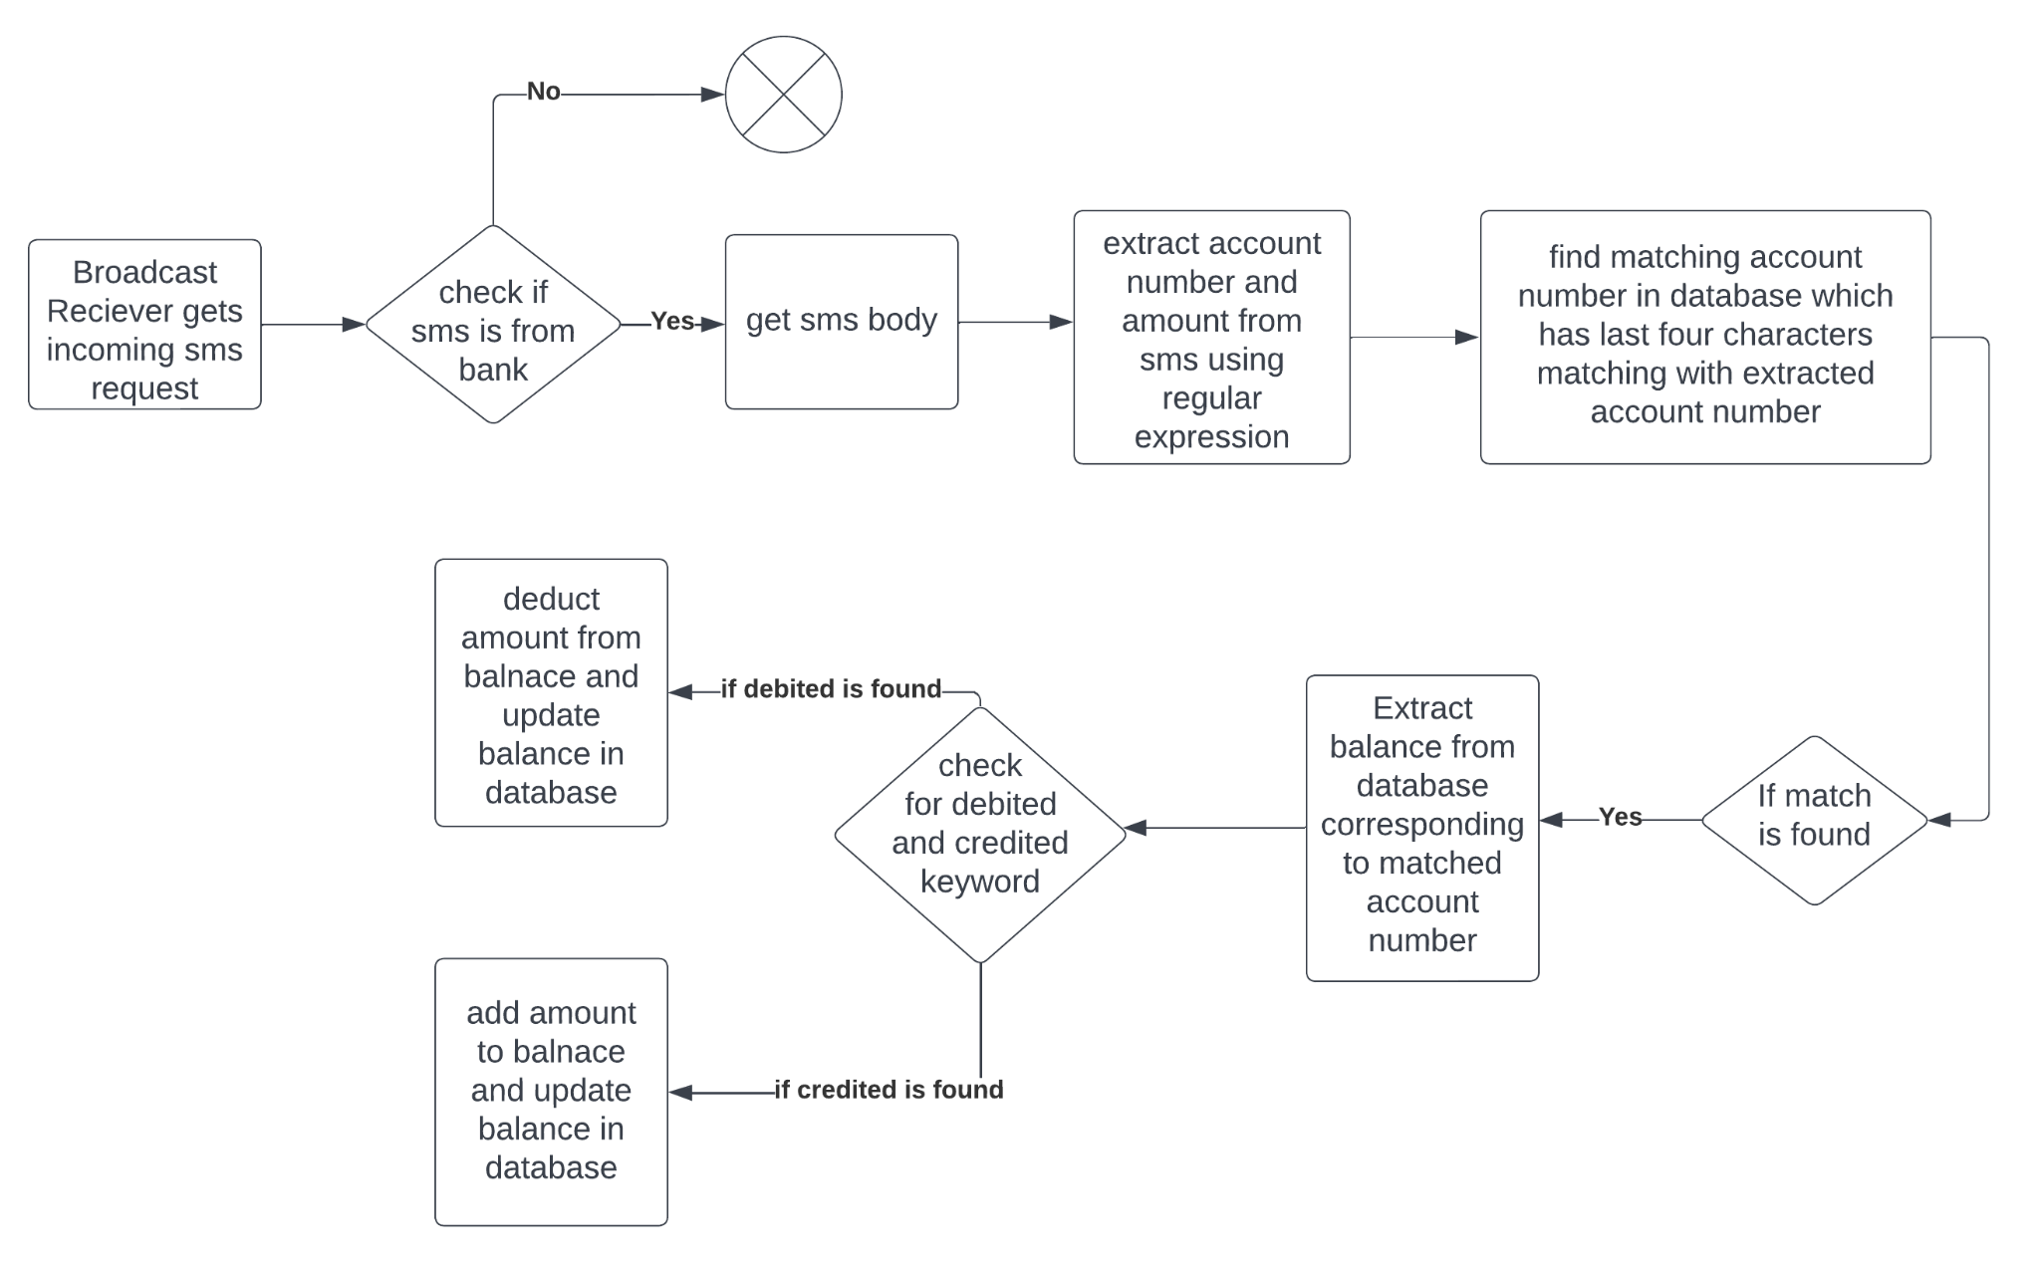

Fig. 4.1: Flowchart of dynamic updation of bank assets

As shown in fig. 4.1 This BroadcastReceiver is set to catch the event SMS_RECIEVED . When it gets that event then incoming sms will be sent to check for specific keywords related to banking . If those keywords are found in sms then amount and account number last 4 digits will be extracted .After getting last 4 digits of account number ,that account number will be matched with account numbers from realtime database. If a match is found then the balance will be extracted from that account number . Now the message body will be searched for debit and credit keywords .if debited keyword is found then amount will be deducted from balance and it will be updated in database and if credited keyword is found then amount will be added to balance and it will be updated in database .

### Adding Nominee to user

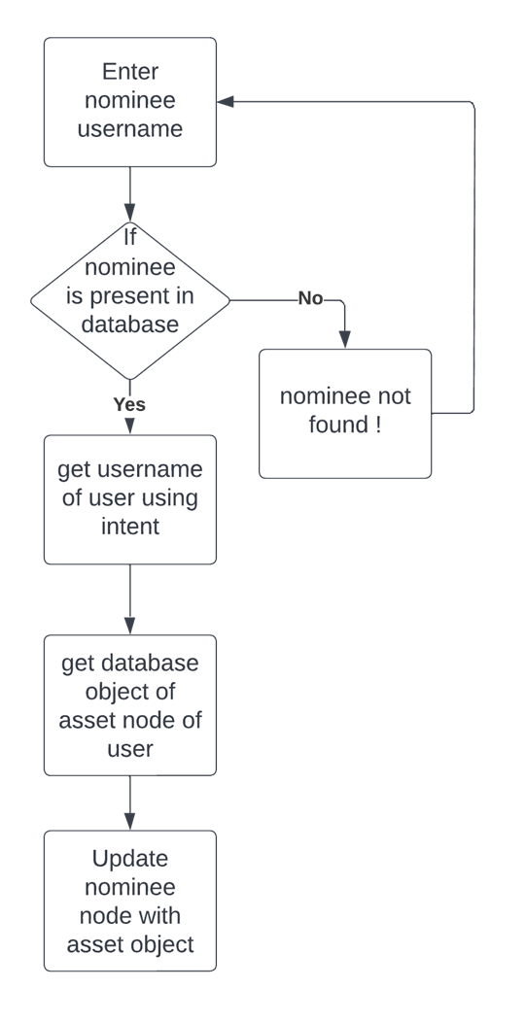

Fig. 4.2: Add nominee flowchart

Adding a nominee is one of the functions of our application. When a user adds a nominee then his assets are cloned into the nominee's profile. This is done using firebase Realtime database and Map object. As shown in fig. 4.2 the user first enters the nominee username he wants to add. That username is then verified with a Realtime database. If that nominee is found, then an asset object is created of the asset node of the user. That object is then updated to the nominee node using updateChildren() method of the database.

### Static pop ups

To display pop up cards of tips or insights Popup menu is used Android has a PopupMenu widget . first invoke PopupMenu constructor and create an object for this with application context. call inflate function of popup object by passing getMenu function of popup and xml file . Now add onitemclicklistener to the popup object and specify what text needs to be displayed. Such popups make users more familiar with the system and makes it easy for users to interact with the system.

### Database Description

We have used the Firebase realtime database in this application. Firebase realtime database is good horizontal scaling is required. Horizontal scaling means nodes in the database don't have a fixed schema for attributes that can be changed dynamically. As shown in fig. 6, Our database has two main nodes,one is for users and other is nominee. Now the user node has name,email , username and password attributes.

Now when an asset is added the user node scales horizontally and an asset as an object is added to the user node. Asset node has tangible and intangible assets . tangible are further divided into bank assets,gold,property,stocks and Intangible assets are further divided into trademark,patent and copyright. All assets have their special attributes .

### Uploading files

Files are uploaded in firebase inside firebase cloud storage. firebase storage is the cloud storage provided by firebase. This stores file as a URL which can be accessed easily.Firstly Firebase storage is added to application and dependencies are included for storage.Firebase storage reference is created with storage reference object.After user clicks edit text Intent opens up to select PDF file from internal memory .

when the user selects file from generated intent then that filename is auto selected. if filename is returned by edittext and request code is 12 then filename in the form of intent data is passed to storageDB using the putfile function to the relevant child node to the database tree and on success the URL is generated by using Tasksnapshot object's getDownloadURL method . The Url is then converted to string and it is stored in relevant child nodes.

## Chapter 5: Result and analysis

1. Add nominee function

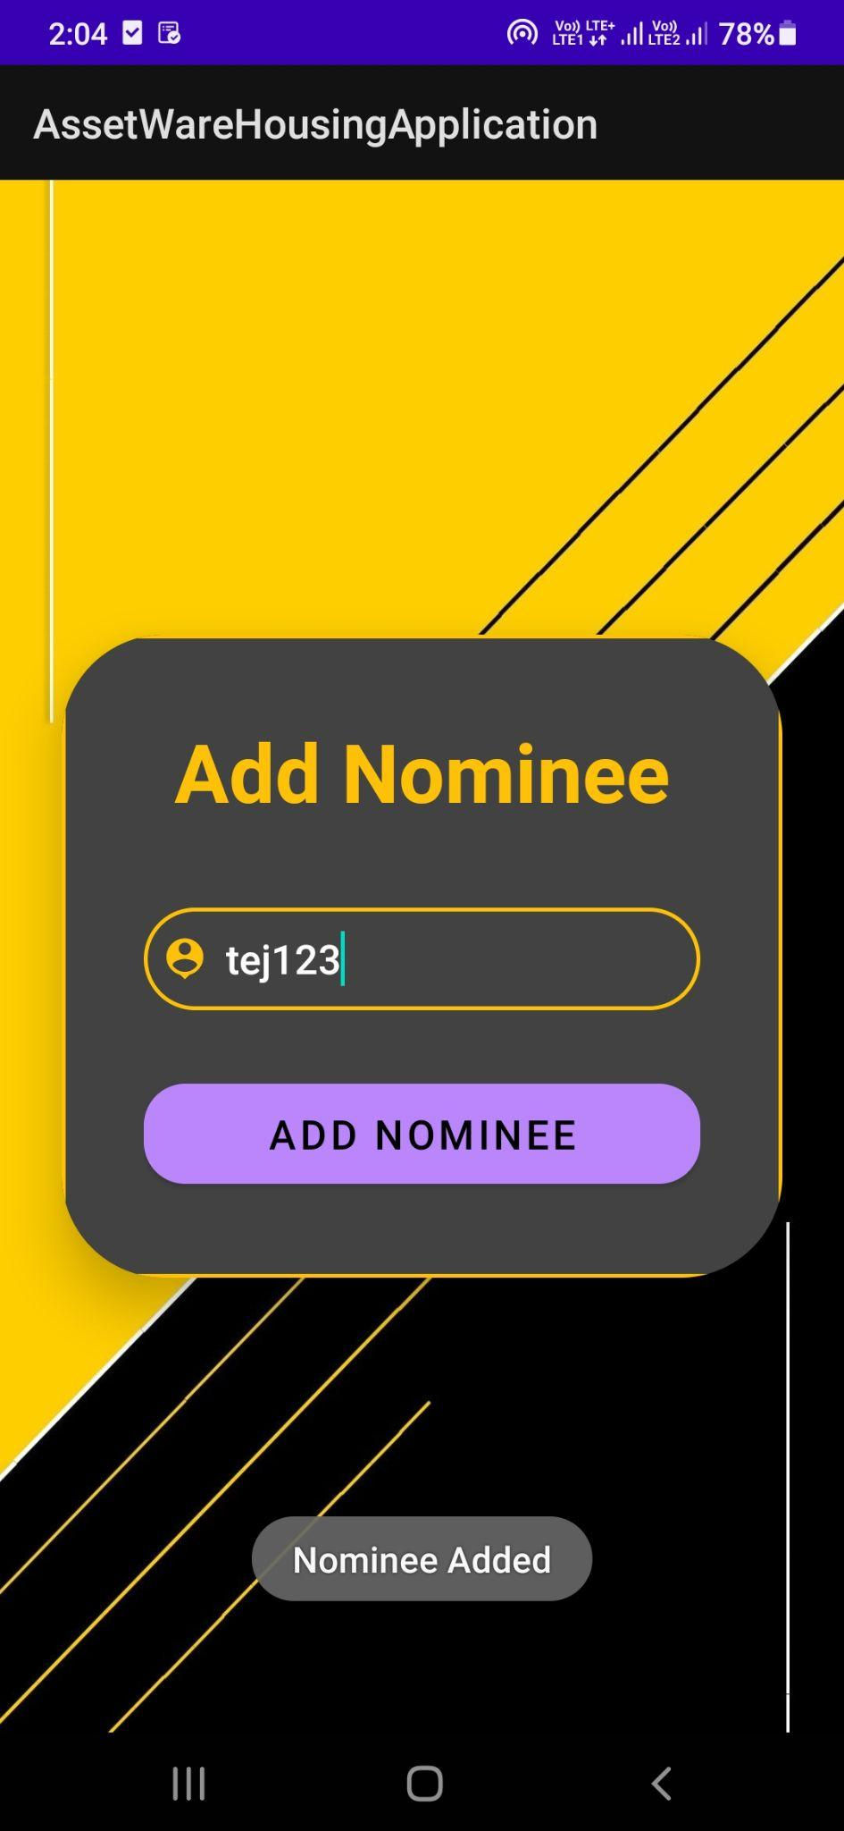 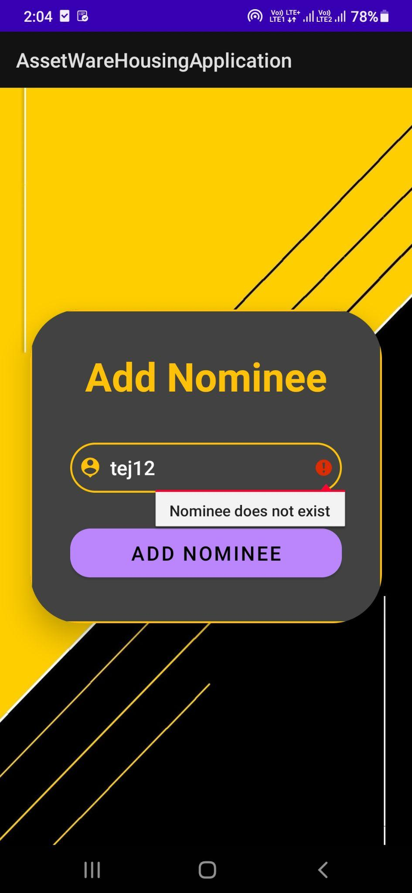

Fig. 5.1:Nominee added screen Fig.5.2: Nominee does not exist error screen

The Add nominee screen is as shown in fig. 5.1. After a user enters a nominee username then that username is matched with the database and if that username is present in the database then Nominee added Toast is generated as shown in Fig. 5.1 . If username is not present then Error text Nominee does not exist is displayed on the screen as shown in fig. 5.2. All assets of the user are cloned or copied into the nominee database if the username is present.

1. Dynamic updation through sms

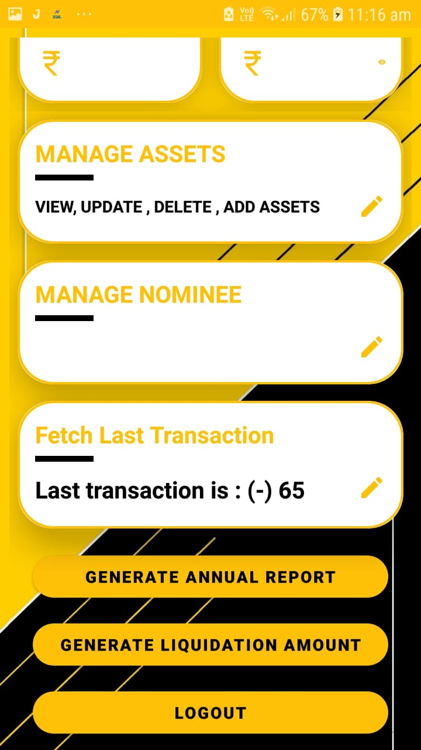

Fig. 5.3: last transaction updated screen

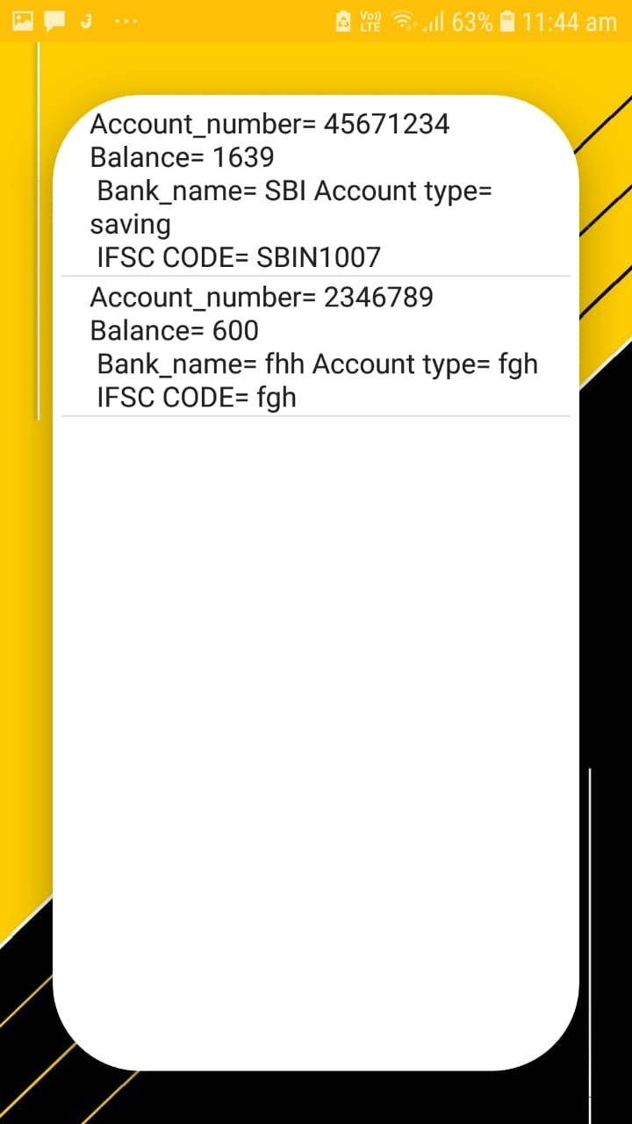 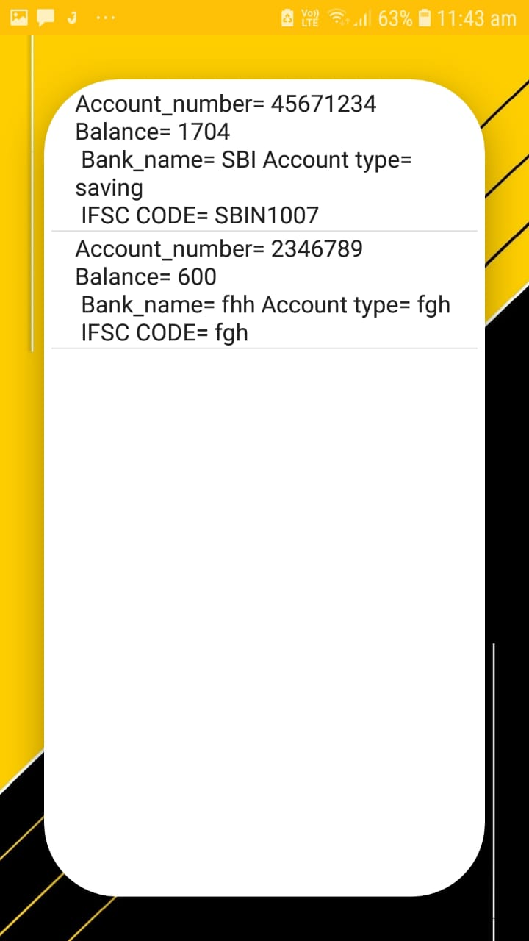 Fig. 5.4: before sms View bank asset screen Fig. 5.6: After sms View bank asset screen

 

Fig.5.5: close view of before sms screen Fig. 5.7: close view of after sms screen

Static updation of balance through sms is done using Broadcast receiver. When sms is delivered to a mobile Phone then the amount and account number is fetched and the balance of that account is updated. As shown in fig. 5.6,5.7 balance of Account number 45671234 is 1704 . After receiving sms of Rs. 65 debited balance changed to 1639 as shown in fig . 5.4,5.5.

Last transaction is also fetched as shown in fig. 5.3. So static updation of balance using sms is working and it is updating balance by extracting account number from sms. Fig. 5.5 and fig.5.7 shows dynamic updation of balance .

## Chapter 6: Conclusion

### 6.1 Conclusion

To make the process of managing assets easier, implemented this asset warehousing application.This is an essential attempt to redefine the way assets (digital,tangible & intangible) will be bequeathed to the desired nominee’s of the deceased. In this Application tried to reduce internet dependency as much as possible but still Internet dependency was not completely eliminated but it was reduced. Dynamic updation for banking transactions and static updation for all other assets was achieved. The nominees were successfully able to get access to the assets of the deceased.

## Chapter 7: References

1. Margaretha Ohyver, Jurike V. Moniaga, Iwa Sungkawa, Bonifasius Edwin Subagyo, Ian Argus Chandra, The Comparison Firebase Realtime Database and MySQL Database Performance using Wilcoxon Signed-Rank Test, Procedia Computer Science,Volume 157,2019,Pages396-405,ISSN1877-0509,<https://doi.org/10.1016/j.procs.2019.08.231>.(<https://www.sciencedirect.com/science/article/pii/S1877050919311500>)
2. Sharma, Divya & Dand, Hiren. (2019). Firebase as BaaS for College Android Application. International Journal of Computer Applications. 178. 1-6.

10.5120/ijca2019918977.

1. G Dhanush and K. G. Mohan, "Integrated adaptable mobile-based platform for university/college management using firebase," International Journal of Engineering Applied Sciences and Technology, vol. 5, pp. 373-378, May 2020, doi: 10.33564/IJEAST.2020.v05i01.062
2. Kumar, Deepak, and Mohammed Abdul Qadeer. "SMS based emerging techniques for monitoring and controlling android mobiles." International Journal of Engineering and Technology 4.6 (2012): 798.
3. Yildirim, Nilay & Varol, Asaf. (2015). Android based mobile application development for web login authentication using fingerprint recognition feature. 2662-2665. 10.1109/SIU.2015.7130436.
4. Mitchell Ratner, Steven Klein “*The Portfolio Implications of Gold Investment*” The Journal of Investing Feb 2008, 17 (1) 77-87; DOI: 10.3905/joi.2008.701958
5. Martin Surya Mulyadi,Yunita Anwar “*Gold versus stock investment: An econometric analysis*”International Journal of Development and Sustainability Online ISSN: 2168-8662 – www.isdsnet.com/ijds

Volume 1 Number 1, June 2012, Page 1-7 ISDS Article ID: IJDS12031001.

1. Aty Herawati & Angger Setiadi Putra, 2018. "The Influence of Fundamental Analysis on Stock Prices: The Case of Food and Beverage Industries," European Research Studies Journal, European Research Studies Journal, vol. 0(3), pages 316-326.
2. The International Financial Reporting Standards Foundation. “IAS 38 IntangibleAsset <https://www.ifrs.org/issued-standards/list-of-standards/ias-38-intangible-assets/>
3. State of California. "Tangible Assets - 7624 “ <https://www.dgs.ca.gov/Resources/SAM/TOC/7600/7624>
4. <https://www.moneycontrol.com/news/business/personal-finance/how-to-bequeath-your-digital-assets-6406221.html>
5. Katy Steinmetz, Your Digital Legacy: States Grapple with Protecting Our Data After We Die, TIME (Nov. 29, 2012), http://techland.time.com/2012/ 11/29/digital-legacy-law/. “Last year, security-software company McAfee surveyed 3,000 people in 10 countries, asking about the financial value they’d assign to assets such as music files and online photo albums: the U.S. average was just under $55,000.” Id
6. <https://www.moneycontrol.com/news/business/personal-finance/how-to-bequeath-your-digital-assets-6406221.html>
7. <https://www.digilocker.gov.in/>
8. <https://khatabook.com/>